https://lh5.googleusercontent.com/DRN4QVuC02ifom_NAMHupC-Z8jry1N9Bn1aTiJJIt9ovHe4Qfi3oNCtpnmX_hZEYhgdIWzxu2sniwwJtUoCWSoRWDSRAdMjO-Bc0bU1LIRW_AVCdJp0FKAFU44-pZFv2jn63r1pf8zVRjyPb7A

SFDC Automatic Deployment

Technical Guide

Version 1.0.0 - July 2016

# Document History

|  |  |  |  |
| --- | --- | --- | --- |
| Date | Version | Description | Author |
| 19/07/2016 | 1.0.0 |  | Diogo Roxo |
|  |  |  |  |

Content

Document History 2

Content 3

OVERVIEW 5

Business Documentation 5

Processes 5

1. Automate OSCAR migration from SAAM 7

Migrate SAAM from Portal 7

Migrate SAAM not from Portal 7

2. Reorganization of OSCAR 7

Rename OSCAR fields / section / steps 7

Create the missing fields in the OSCAR 7

Review the layout of the OSCAR 7

3. Enhancements on the OSCAR 7

Wizard: prepopulate fields for new BR and new SA using HO's values 7

Align record owner for OSCAR and communication case 7

Enhance the hierarchy left panel on the account view 7

Fill “Type of customer” on the communication case 7

Fill properly the field “Case area” on Communication case 7

Recalculation of deadline for sanity checks 8

Review Statuses on OSCAR and communication case 8

4. Review the left side panel for agency changes: when sanity checks are passed, master data have to be updated 8

Review the left side panel for agency changes: when sanity checks are passed, master data have to be updated 8

5. Keep ownership data aligned between HO and branches 8

Improve the wizard to prepopulate owners data for new BR, new BR abroad and SA. 8

Improve the wizard to prepopulate owners data for agency changes and correction~ 8

Lock owners data in the "Manage owners" page for new agencies with a parent account 8

Add a validation to ensure that all the hierarchy is selected in hierarchy account selection for change of shareholding 8

Change the way owners/contacts are pushed to master data for oscar corrections. 9

6. Implement validations 9

Wizard: new BR, new BR abroad, and new SA must have a parent account 9

Wizard: the processes can start only if the account has the proper location type 9

7. Sprint Components 9

# OVERVIEW

This document describes a tool to perform an automatic deployment into a Salesforce Environment.

In the examples below it was used a Developer Sandbox.

# Requirements

In order to work with this tool you need to install:

1. Install Python 3.5.1(<https://www.python.org/downloads/> ). Be sure you created the environment variables.

# Processes

## Automate OSCAR migration from SAAM

### Migrate SAAM from Portal

Details here

### Migrate SAAM not from Portal

1. Details here

## Reorganization of OSCAR

The Oscar object (AMS_OSCAR__c) suffered some small changes as specified in the document “Reorganization of OSCAR 29-06-2016.doc” attached.

### Rename OSCAR fields / section / steps



|  |  |  |
| --- | --- | --- |
| **Existing Field Name** | **New Field Name** | **Remarks** |
| **Message - “ *IATA Code Bypassed*”** | “*IATA Code already generated*” | message displayed if the User attempts to generate another IATA Code |
| **Proof of Payment Received** | Confirm Payment Received | Field in the OSCAR |
| **Billing Doc. Number** | Invoice Number | Updated Fields in the OSCAR. |
| **Effective Date** | Change Effective as of |
| **Sanity Check Deadline** | Deadline Date |
| **Validate Qualification Criteria (KC01)** | Validate Qualification Criteria (KC03) | Updated only for  “Agency Changes” |
| **Sanity check received** | Sanity check completed |  |
| **All the checkboxes wording “Send”** | “… Sent” |  |

### Create the missing fields in the OSCAR

|  |  |
| --- | --- |
| **New Field Name** | **Proposed Field Name** |
| **New Interaction** | Added to the Oscar for all processes. |
| **Regions** | Added to the Oscar Communication Case for all processes. |
| **Case History** | Added to the Oscar Communication Case for all processes. |
| **Log a Call** | Added to the Oscar Communication Case for all processes. |
| **Activity History** | Added to the Oscar for all processes. |
| **Dossier Reception Date** | Added to the Oscar for all processes. |
| **Task** | Added to the Oscar for all processes. |
| **Documentation Remarks** | Added to the Oscar for all processes in the Application Receipt Section. |
| **Criteria Remarks** | Added to the Oscar for all processes in the Application Processing Section. |
| **Case Remarks** | Added to the Oscar for all processes. |
| **Run Reports** | Added custom link in the case tab to go directly to “Oscar with cases” report type. |
| **Country Specifics** | Added checkboxes to HO and BR OSCAR for the steps:  Approval, Disapproval and Rejection |
| **Update AIMS** |
| **Close IFAP** | Added checkboxes to HO and BR OSCAR for the steps:  Disapproval and Rejection |
| **Cancel Inspection Requests** |
| **Financial Year** | Added to HO OSCAR. |
| **Financial Statements Submission Deadline** | Added to HO OSCAR. |
| **Parent Case** | Added to Communication Case. |
| **Key customer** | Added to Communication Case. |

1. These new fields were added to the layouts: AMS_OSCAR__c 🡪 NEW, AMS_OSCAR__c 🡪 CHANGE and CASE 🡪 OSCAR_Communication__c.

### Review the layout of the OSCAR

1. **Modifications to the Oscar Layouts (**“New” and “Change”**)**

|  |  |
| --- | --- |
| **Field Name** | **Action** |
| OSCAR Status | OSCAR Status hidden from OSCAR Central Panel. Repeated on top of OSCAR Panel and in Central Panel, which can be confusing |
| CASS Number | Moved CASS Number field next to IATA Code field so that the Analyst will not forget to manually update CASS Number. |
| Reject Approval | Removed from Manager Approval |
| Reject Disapproval |

## Enhancements on the OSCAR

### Wizard: prepopulate fields for new BR and new SA using HO's values

1. Details here

### Align record owner for OSCAR and communication case

1. Details here

### Enhance the hierarchy left panel on the account view

The Hierarchy tab in the Account left side panel view was changed in order to always display the full hierarchy of the current account. For HO, BR and SA it will always be presented the same tree. The only difference is that the account in context will appear in highlighted with the name in bold. Example below:

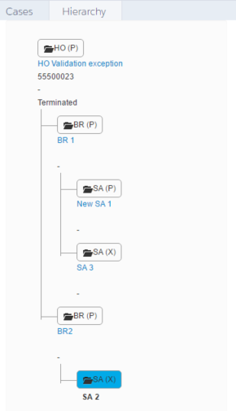

For this implementation where modified the following entities:

* src/classes/AMS_DemoTreeview.cls
* src/pages/AMS_DemoTreeViewPage.page

### Fill “Type of customer” on the communication case

1. Details here

### Fill properly the field “Case area” on Communication case

1. Details here

### Recalculation of deadline for sanity checks

1. Details here

### Review Statuses on OSCAR and communication case

1. Details here

## Review the left side panel for agency changes

### Review the left side panel for agency changes: when sanity checks are passed, master data have to be updated

The existent automatism to Update master data (used for example when in the IATA Code generation) was added in the “Application Receipt’ -> ‘Preform Sanity Check” to the OSCAR process “Agency Changes” (field Process__c = ‘MAJOR.CHANGES’).

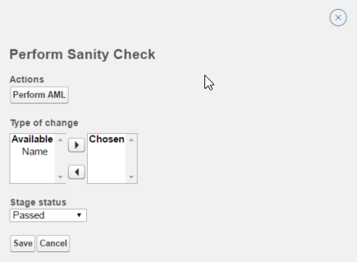

In this way, when the status of the Step “Perform sanity check” is set to “Passed” the master data is updated with the data present in the staging Area (added in AMS_OSCARTriggerHandler.cls).

In the Step “Change Disapproval” -> ” Disapproval Finalization” it was added a new checkbox Roll back account data (Roll_back_account_data__c) in order to remind the user that he needs to rollback data on the account level. When the user selects this checkbox and clicks save a new date field “Account_data_rolled_back__c” is saved with the current date (added in AMS_OSCARTriggerHandler.cls).

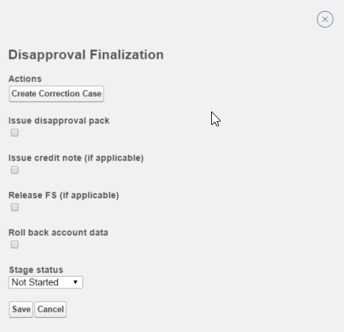

The rollback is managed by a correction case. The new button “Create Correction Case” (in the AMS_OSCAR__c object) creates a new correction case and then the analyst will check in the account history which fields were updates and what was the old values. He will fill the correction case with the previous values and finalize it in order to update the account.

## Keep ownership data aligned between HO and branches

### Improve the wizard to prepopulate owners data for new BR, new BR abroad and SA.

1. Details here

### Improve the wizard to prepopulate owners data for agency changes and correction~

1. Details here

### Lock owners data in the "Manage owners" page for new agencies with a parent account

1. Details here

### Add a validation to ensure that all the hierarchy is selected in hierarchy account selection for change of shareholding

1. Details here

### Change the way owners/contacts are pushed to master data for oscar corrections.

1. Details here

## Implement validations

### Wizard: new BR, new BR abroad, and new SA must have a parent account

1. Details here

### Wizard: the processes can start only if the account has the proper location type

1. Details here

## Sprint Components

Below is the list of components created/updated for this Sprint:

|  |
| --- |
| src/classes/AMS_OSCARTriggerHandler.cls |
| src/objects/AMS_OSCAR__c.object |
| src/staticresources/JSON_OSCAR_Process.resource |
| src/classes/AMS_Utils.cls |
| src/triggers/AMS_OSCARTrigger.trigger |
| src/classes/AMS_OSCAR_ProcessViewerController.cls |
| src/layouts/Case-OSCAR Communication.layout |
| src/classes/AMS_DemoTreeview.cls |
| src/pages/AMS_DemoTreeViewPage.page |
| src/layouts/AMS_OSCAR__c-OSCAR Layout Changes.layout |
| src/layouts/AMS_OSCAR__c-OSCAR Layout.layout |